A000-AM,C-Taino-Cohoba Inhaler-Owl Cemi-Manatee bone-1000 CE

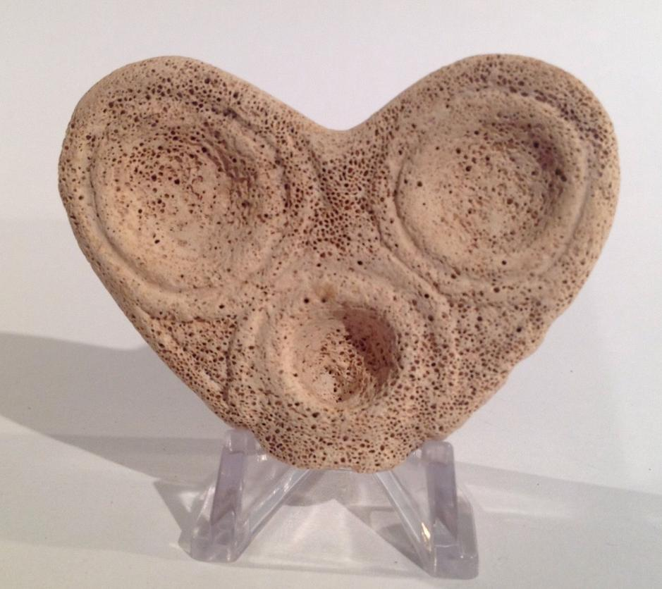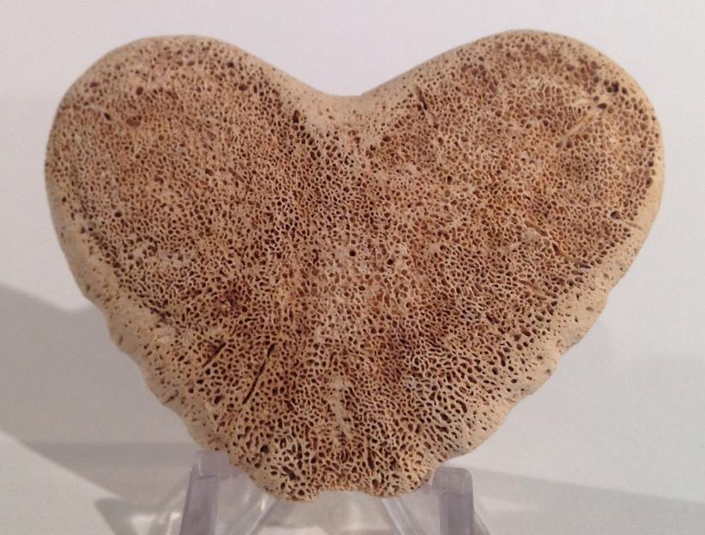

Figs. 1-2. AM,C-Taino-Cohoba Inhaler-Owl Cemi-Manatee bone-1000 CE

**Case No.: 18**

**Accession No.**

**Formal Label:** AM,C-Taino-Cohoba Inhaler-Owl Cemi-Manatee bone-1000 CE

**Display Description:**

The inhaler is made from the end of a vertebrae probably a young manatee. The two large eyes suggest subject is an owl. The owl in Taino mythology is an important seer into the dark recesses of the night and of existential reality. In this application of the owl, the assistance to the cohoba inhaler is to provide help along the way to having a positive hallucinogenic experience. The mouth of this “Owl” cemi is the cohoba receptacle connected at the chin by a short drilled channel into which would be inserted a forked tube which was then inhaled by the nostrils.

**LC Classification:**

**Date or Time Horizon: 1000 CE**

Geographical Area: Originally from the Dominican Republic.

**Map:**

**GPS coordinates:**

**Cultural Affiliation:**

**Media:**

**Dimensions:** Width 7.1cm or 2.8".

**Weight:**

**Condition:**

**Provenance:** Originally from the Dominican Republic.

**Discussion:**

**References:**